AI Product Description & SEO Prompt Toolkit

Made By: Yashika Aggarwal

Overview

Introduction
This project focuses on building a non-coding AI-powered prompt toolkit that generates product descriptions, SEO titles, meta descriptions, and social media hashtags for e-commerce products. The system uses structured prompts and Google Sheets to organize product input and AI-generated output efficiently. The goal is to simplify content creation using artificial intelligence tools without coding.

Objectives of the Project
- To understand prompt engineering
- To learn how AI generates marketing content
- To create SEO-optimized product descriptions
- To organize product data systematically
- To explore real-world applications of AI in e-commerce

Tools Used
- Google Sheets
- ChatGPT
- Microsoft Word (for documentation)
- Notion(prompt tool kit)
- Make.com(for workflow)

Project Workflow (Very Important)
Step 1: Product details are entered into Sheet 1 (Product_Input).
Step 2: Product features and benefits with 3 versions of descriptions are structured in Sheet 2 (SEO)..
Step 3: The generated content is stored in Sheet 3 (Features).

Explanation of Each Sheet
- Sheet 1 – Product_Input
Stores product name, category, target audience, tone, keywords and description.
- Sheet 2 – SEO
Stores AI-generated SEO titles,meta descriptions,hashtags,extra keywords with 3 vesions of description(emotional,technical,short)
- Sheet 3 – Features
Maps product features to descriptions ,customer benefits and emotions.

Advantages of the System
- Saves time in content creation
- Improves SEO structure
- Maintains consistency in product listings
- Easy to scale for multiple products
- No coding required

Limitations
- Requires manual input
- AI output may need minor editing
- SEO performance depends on keyword quality

Conclusion
This project demonstrates how structured prompts and AI tools can automate and simplify e-commerce content creation. By organizing product data and using reusable prompts, high-quality SEO content can be generated efficiently without technical knowledge.

Sample Output:

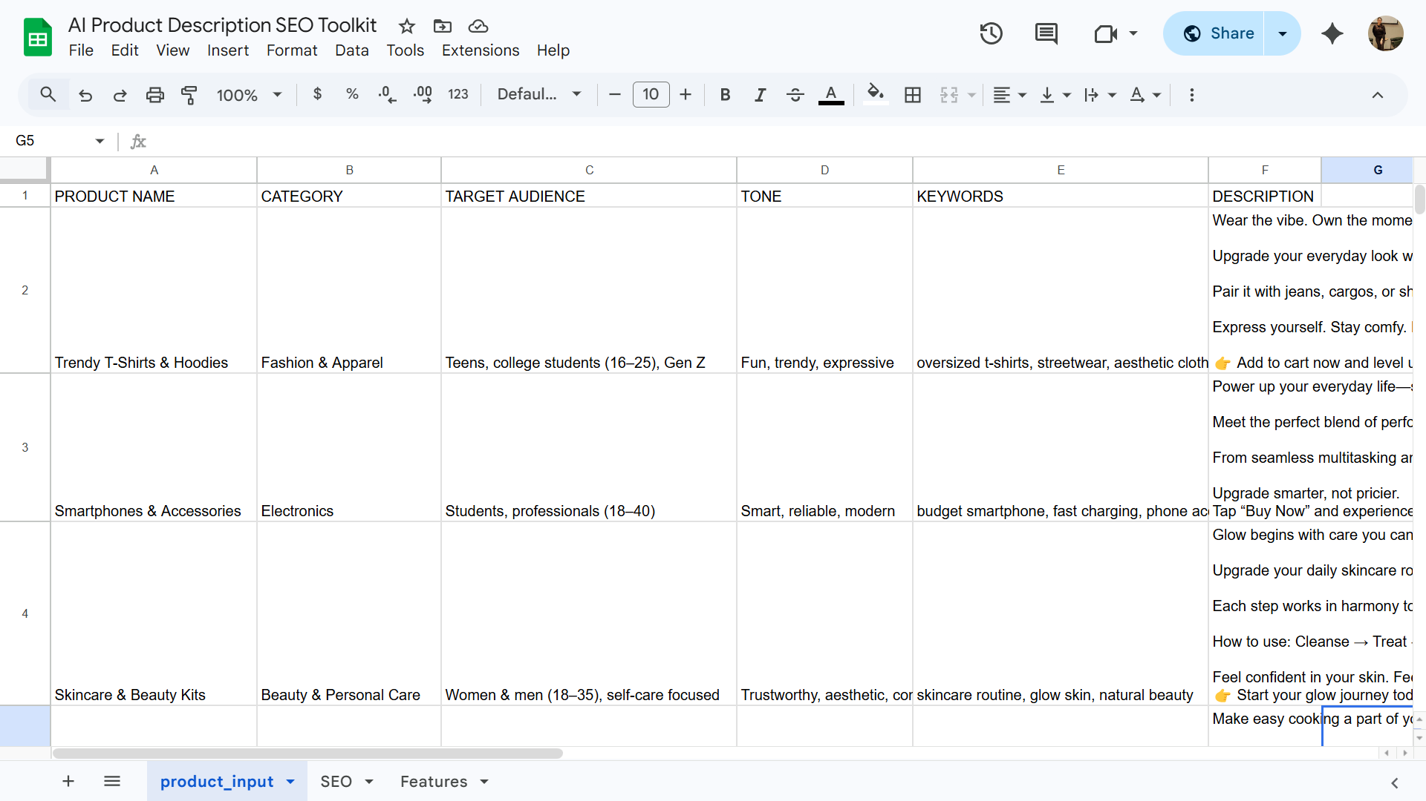

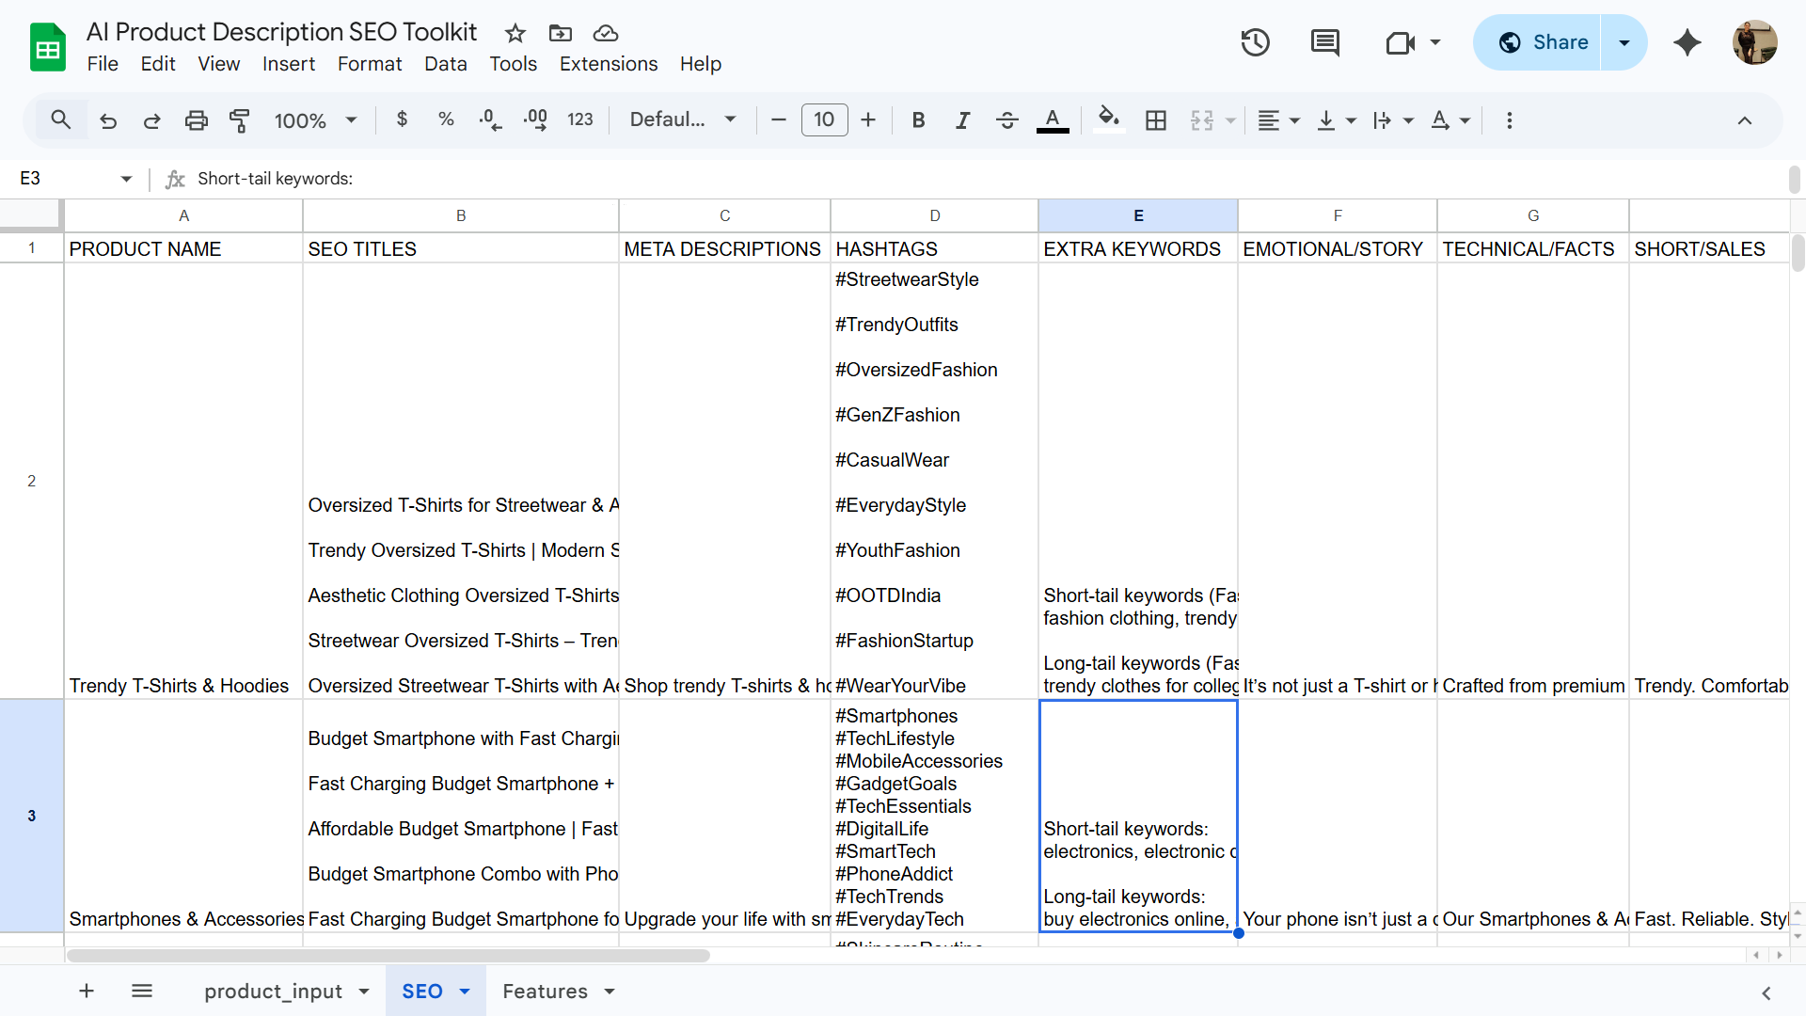

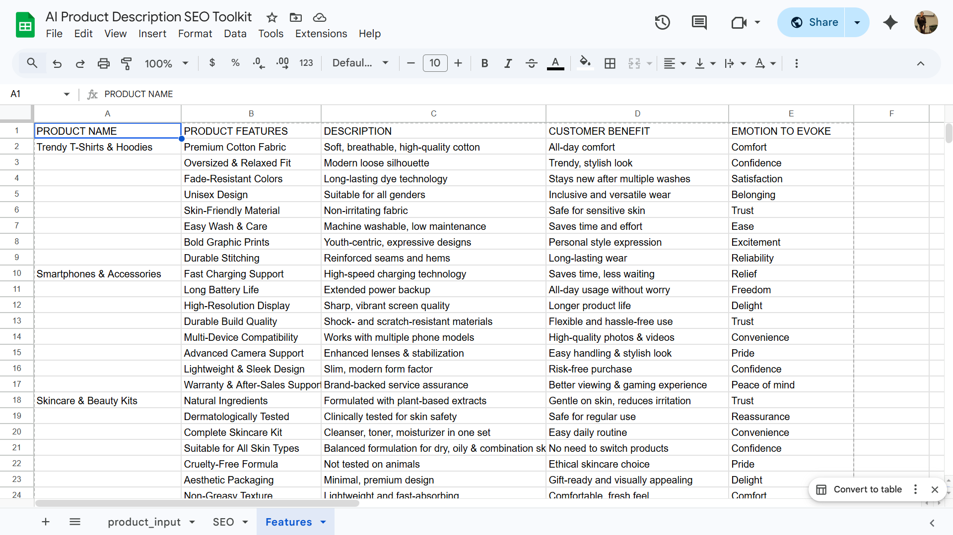

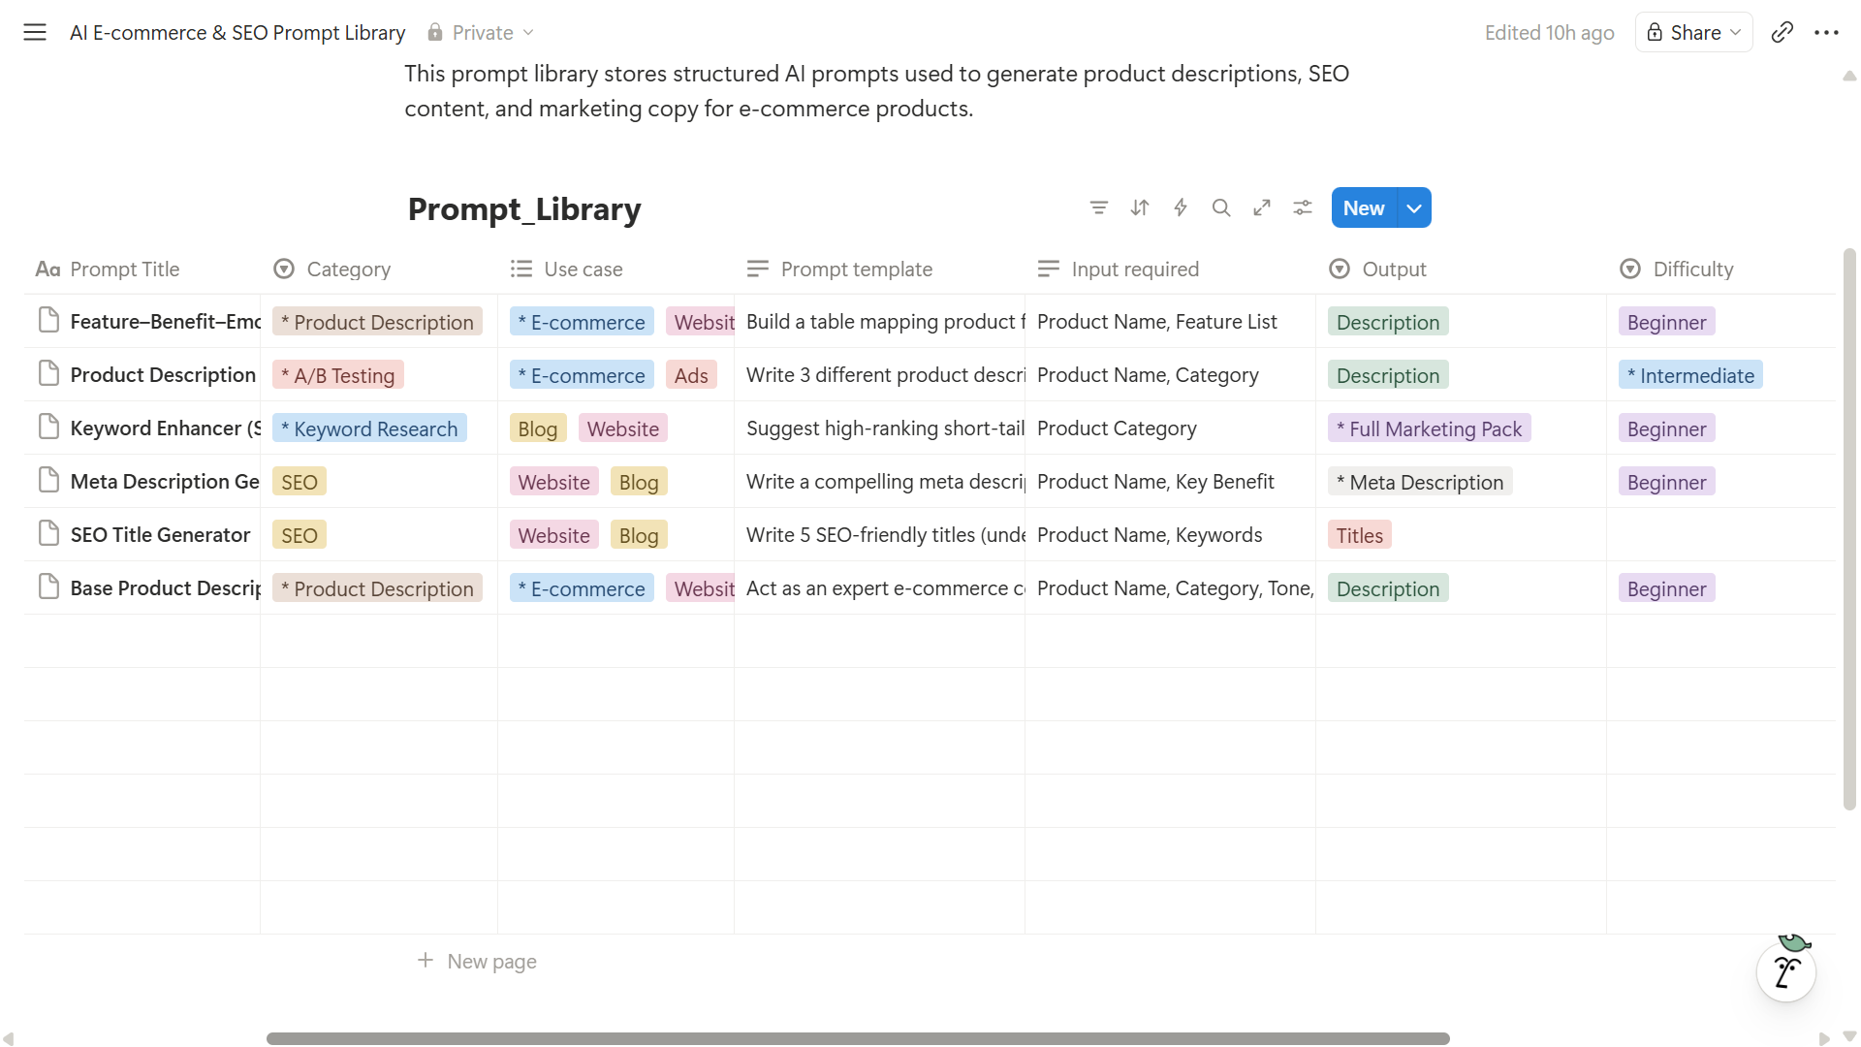

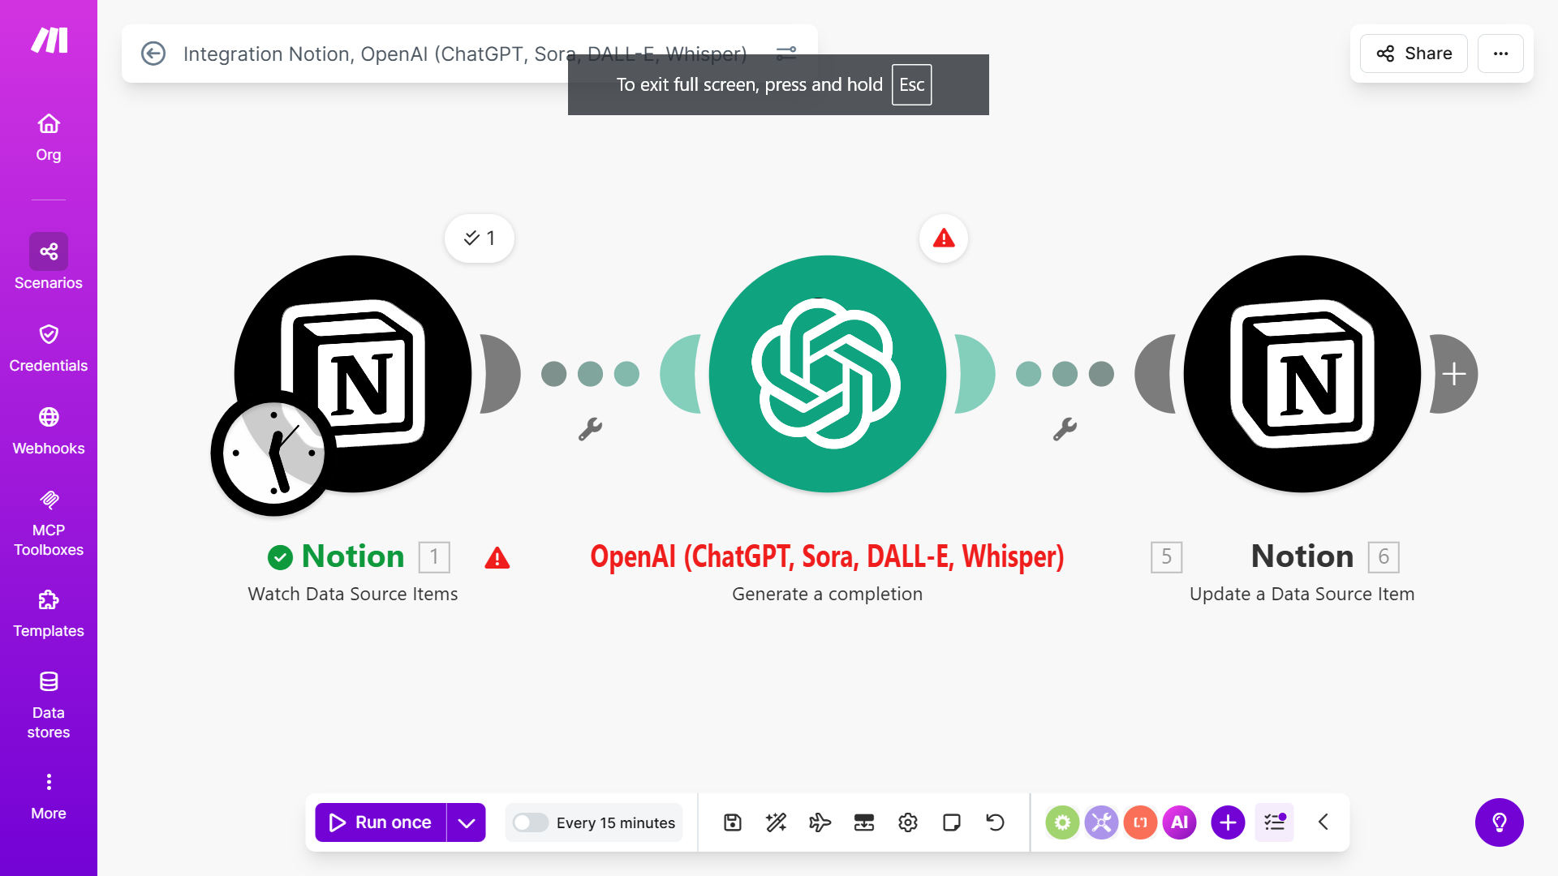

Prompts

Sheet 1
Suggest 10 popular e-commerce product categories and ideal target audiences for each Product Name | Category | Target Audience | Tone | Keywords
For description:
Act as an expert e-commerce copywriter.
Write a product description for [Product_Name] under the [Category] category.
Tone: [Tone].
Highlight key benefits, usage, and emotional appeal.
Keep it under 150 words.
Optimize for SEO with these keywords: [Keyword_List].
Include a catchy opening line and call-to-action.

Sheet 2
SEO Title Generator:
Write 5 SEO-friendly titles (under 60 characters) for [Product_Name] using these keywords: [keywords].
Meta Description Generator:
Write a 150-character meta description for [Product_Name] with a focus on benefits and call-to-action.
Hashtag Generator:
Suggest 10 high-engagement hashtags for Instagram and LinkedIn promotion of [Product_Name].
Keyword Enhancer:
Suggest long-tail and short-tail keywords to improve SEO ranking for [Category].

3 versions of description:
Write 3 different product descriptions for [Product name] with varying tones: 1. Emotional & storytelling 2. Technical & factual 3. Short & conversion-focused in tabular form

Sheet 3
Act as a product marketing strategist.
For the product: [Product Name]
List 5 important product features.
For each feature, provide:
- Short description
- Customer benefit
- Emotion it should evoke in the buyer
Present the output in table format with columns:
Feature | Description | Customer Benefit | Emotion

Project Link

https://docs.google.com/spreadsheets/d/1HLxMFYbxGIok2U-tJLa1S4LAhPQGhj5B8ARXJd470DA/edit?usp=sharing

https://www.notion.so/AI-E-commerce-SEO-Prompt-Library-31322e39e751802aadeecaaaf44f2152?source=copy_link

https://eu1.make.com/public/shared-scenario/DxMWGvX7k1J/integration-notion-open-ai-chat-gpt-sor

